AWS Lambda allows us to run our code without provisioning or managing servers. Instead of launching EC2 instances, installing software, configuring operating systems, and maintaining infrastructure, AWS automatically handles all of that for us.
We only upload our code, configure a trigger, and Lambda executes our code whenever the trigger occurs."

What is AWS Lambda?
"AWS Lambda is a serverless compute service.
The word serverless doesn't mean there are no servers. It means AWS manages the servers for us. We don't know where our application is running, which EC2 instance is used, or how many servers are involved.
Our responsibility is only to write the business logic.
AWS automatically handles:
- Server provisioning
- Operating system maintenance
- Capacity planning
- Scaling
- Availability
- Security patches
This allows developers to focus entirely on writing application code."

Why do we use Lambda?
"Before Lambda, if we wanted to execute a small task, we had to launch an EC2 instance.
For example:
Suppose someone uploads an image.
To resize that image, we needed:
- An EC2 instance
- Operating System
- Storage
- Web server
- Monitoring
- Scaling
Even if image uploads happened only once per hour, the EC2 instance had to remain running continuously.
This resulted in unnecessary infrastructure cost.
AWS Lambda solves this problem.
The function runs only when an event occurs.
If no event occurs, no compute resources are used.
Therefore, we only pay for actual execution time."

Why is it called Serverless?
"The term Serverless often confuses beginners.
Actually, servers do exist.
The difference is:
In EC2:
- We manage the servers.
In Lambda:
- AWS manages the servers.
AWS automatically provisions infrastructure,
installs operating systems,
scales instances,
and removes idle resources.
We simply upload our code."

How Lambda Works
"The Lambda workflow is very simple.
Step 1:
An event occurs.
Example:
Someone uploads a file to an S3 bucket.
Step 2:
S3 sends an event notification.
Step 3:
AWS automatically invokes the Lambda function.
Step 4:
Lambda processes the file.
Step 5:
Results are stored back into S3 or another AWS service.
No manual intervention is required."

Event Driven Architecture
"Lambda works based on events.
Unlike EC2 applications that run continuously,
Lambda runs only when triggered.
This model is called Event-Driven Architecture.
Some common events are:
- File upload
- API request
- Database update
- Scheduled job
- Message queue
- CloudWatch alarm
Whenever an event occurs,
Lambda automatically executes."

Lambda Triggers
"A trigger is simply an AWS service that invokes Lambda.
Common triggers include:
Amazon S3
When a file is uploaded.
API Gateway
When an HTTP request is received.
CloudWatch
For scheduled jobs.
EventBridge
For event routing.
DynamoDB Streams
When table data changes.
SNS
When notifications are published.
SQS
When new messages arrive.
Kinesis
For streaming data."

Programming Languages Supported

"Lambda supports multiple programming languages.
Some popular ones are:
- Python
- Java
- Node.js
- C#
- Go
- Ruby
Python is the most commonly used language because it is simple and has excellent AWS SDK support."

Lambda with API Gateway
"Lambda is commonly used with API Gateway.
When a client sends an HTTP request,
API Gateway invokes Lambda.
Lambda performs business logic.
It may:
- Read data
- Insert records
- Update databases
Finally,
the response is returned through API Gateway."

Advantages of Lambda
"The major advantages are:
No server management
Automatic scaling
Pay only for execution
High availability
Fast deployment
Supports multiple languages
Easy integration with AWS services
Reduced operational overhead."

Disadvantages
"Lambda also has some limitations.
Maximum execution time is 15 minutes.
Cold starts may introduce small delays.
Memory is limited.
Long-running applications are not suitable.
Debugging distributed serverless applications can be more challenging.
Large deployment packages increase startup time."
CASE-1 :
Create an S3 bucket [mydemolambda123789] Create a Lambda function (Python). Paste the Python code to print bucket name, file name, and file size. Click Deploy.

Objective
The objective of this lab is to:
- Create an Amazon S3 bucket named mydemolambda123789.
- Create an AWS Lambda function using Python.
- Configure the Lambda function to process S3 event information.
- Write Python code to print:
  - S3 bucket name
  - Uploaded file name
  - File size
- Deploy and test the Lambda function.

📋 Prerequisites
Before starting this lab, make sure you have:

1. AWS Account
- An active AWS account.
- Access to the AWS Management Console.

2. IAM Permissions
Your IAM user/role should have permissions to work with:
- Amazon S3
  - Create bucket
  - Upload objects
  - Configure notifications
- AWS Lambda
  - Create and deploy Lambda functions
  - Configure triggers
- Amazon CloudWatch
  - View Lambda execution logs

3. Basic Python Knowledge
You should understand basic Python concepts such as:
import
def
print()

4. AWS Region
Choose an AWS Region where you want to create the resources.
For example:
Asia Pacific (Mumbai) - ap-south-1
Make sure you use the same region for the S3 bucket and Lambda function, especially when configuring the S3 trigger.

5. S3 Bucket Name
Use the following bucket name:
mydemolambda123789
Important: S3 bucket names must be globally unique. If AWS says the bucket name is already taken, use another unique name.

6. Lambda Runtime
Select:
Python 3.x
For example:
Python 3.12

7. Lambda Execution Role
Lambda needs an execution role so that it can write execution information to CloudWatch Logs.
You can create a new role with basic Lambda permissions, such as:
AWSLambdaBasicExecutionRole

Lab Architecture
User
|
| Upload file
↓
┌─────────────────┐
│ S3 Bucket │
│ mydemolambda... │
└────────┬────────┘
│
│ S3 Event
↓
┌─────────────────┐
│ AWS Lambda │
│ Python │
└────────┬────────┘
│
↓
┌─────────────────┐
│ CloudWatch │
│ Logs │
└─────────────────┘

Step 1 — Create an S3 Bucket
Go to:
AWS Console → S3 → Create bucket
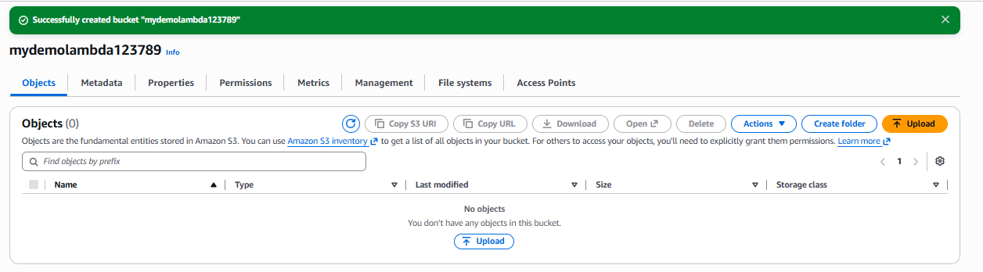

Step 2 — Create Lambda Function
Go to:
AWS Console → Lambda → Functions → Create function
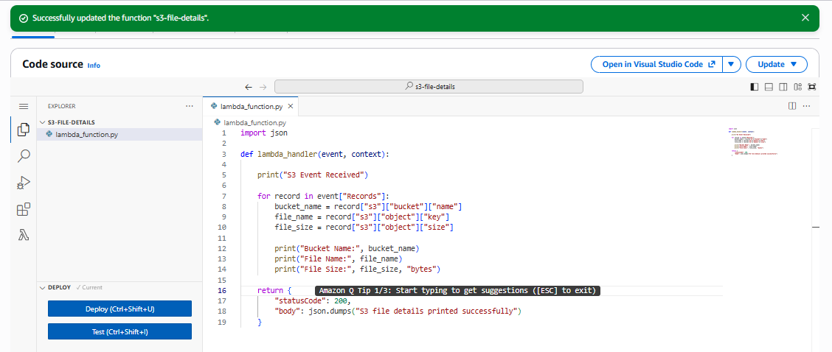

Step 3 — Understand the Code
When a file is uploaded to S3, S3 sends an event to Lambda.
The event contains information like:
Records
└── s3
├── bucket
│ └── name
│
└── object
├── key
└── size
The code extracts:
bucket_name = record["s3"]["bucket"]["name"]
This gives the bucket name.
file_name = record["s3"]["object"]["key"]
This gives the uploaded file name.
file_size = record["s3"]["object"]["size"]
This gives the file size in bytes.

Step 5 — Add S3 Trigger
Now connect S3 to Lambda.
In your Lambda function:
Function overview → Add trigger
Select:
Source:
S3
Select your bucket:
my-lambda-s3-demo-2026
Event type:
All object create events
For example:
s3:ObjectCreated:*
Acknowledge the recursive invocation warning if shown.
Click:
Add
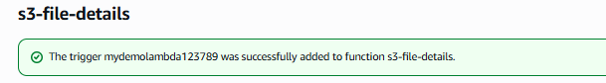

Step 6 — Upload a File to S3
Go to:
S3 → Your Bucket → Upload
Upload a test file.
For example:
test.txt
Click:
Upload
S3 should generate an event and invoke your Lambda function.
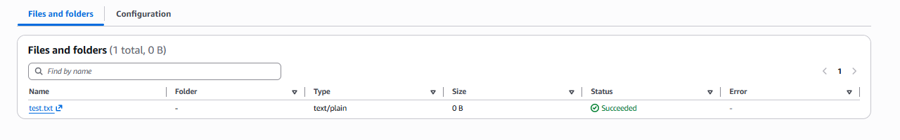

Step 7 — Check Lambda Logs
Go to:
Lambda → s3-file-details → Monitor → View CloudWatch logs
Open the latest log stream.
You should see something similar to:
S3 Event Received
Bucket Name: my-lambda-s3-demo-2026
File Name: test.txt
File Size: 25 bytes
The exact file size depends on your file.

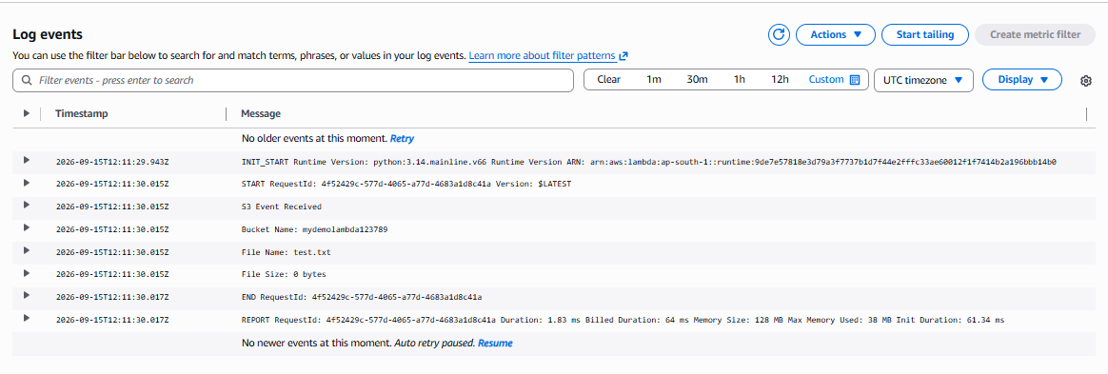

Case2 :
Upload a file to the S3 bucket. Lambda runs automatically. Check CloudWatch Logs to see the bucket name, file name, and file size.

Objective :
To configure an event-driven AWS workflow where:
- A file is uploaded to an Amazon S3 bucket.
- The S3 upload generates an Object Created event.
- The event automatically invokes an AWS Lambda function.
- Lambda processes the event using Python.
- The Lambda output is written to Amazon CloudWatch Logs.
- CloudWatch Logs displays:
  - Bucket name
  - File name
  - File size

Architecture
Upload File
|
▼
┌──────────────┐
│ S3 Bucket │
└──────┬───────┘
│
ObjectCreated Event
│
▼
┌──────────────┐
│ Lambda │
│ Python │
└──────┬───────┘
│
▼
┌─────────────────┐
│ CloudWatch Logs │
└─────────────────┘
│
▼
Bucket Name
File Name
File Size

Prerequisites :
Before starting, you should have:

AWS Account
An active AWS account with access to:
- Amazon S3
- AWS Lambda
- Amazon CloudWatch

IAM permissions
Your IAM user/role should have permissions to:
- Create/manage S3 buckets
- Create/manage Lambda functions
- Configure Lambda triggers
- View CloudWatch Logs
For a lab environment, appropriate administrative permissions can be used, but in production follow least-privilege permissions.

Resources from Case 1
You should already have:
S3 Bucket:
my-lambda-s3-demo-2026

Lambda Function:
s3-file-details
And the Lambda function should contain:
import json

def lambda_handler(event, context):

print("S3 Event Received")

for record in event["Records"]:
bucket_name = record["s3"]["bucket"]["name"]
file_name = record["s3"]["object"]["key"]
file_size = record["s3"]["object"]["size"]

print("Bucket Name:", bucket_name)
print("File Name:", file_name)
print("File Size:", file_size, "bytes")

return {
"statusCode": 200,
"body": json.dumps("S3 file details printed successfully")
}

Step-by-Step Implementation

Step 1 — Open S3
Go to:
AWS Console → S3
Click:
Buckets
Open the bucket created in Case 1.
For example:
my-lambda-s3-demo-2026

Step 2 — Verify Lambda Trigger
Go to:
AWS Console → Lambda → Functions
Open:
s3-file-details
In the Function overview, verify that S3 is connected as a trigger.
You should see something similar to:
S3
|
▼
s3-file-details
If the trigger is not present:
Add trigger → S3
Configure:
Source:
S3

Bucket:
my-lambda-s3-demo-2026

Event type:
All object create events
For this lab, you can use:
s3:ObjectCreated:*
Click:
Add

Step 3 — Verify Lambda Permissions
Go to:
Lambda → s3-file-details → Configuration → Permissions
Check the Execution role.
The Lambda execution role should have permission to write logs to CloudWatch.
Typically, the role will contain the AWS managed policy:
AWSLambdaBasicExecutionRole
This provides the basic permissions required for Lambda to write logs to CloudWatch Logs.
Lambda does not need S3 read permission merely to read the bucket/file information from the S3 event. The bucket name, object key, and object size are included in the event notification.

Step 4 — Upload a Test File
Now go to:
S3 → my-lambda-s3-demo-2026 → Objects
Click:
Upload
Then:
Add files
Select a test file from your computer.
For example:
test.txt
Click:
Upload
You should see:
Upload succeeded

Step 5 — What Happens Automatically?
When the file is uploaded, S3 generates an event:
ObjectCreated
The event is sent to Lambda.
The flow is:
test.txt
|
▼
S3 Upload
|
▼
ObjectCreated Event
|
▼
Lambda Invocation
|
▼
Python Code Executes
|
▼
print()
|
▼
CloudWatch Logs
You do not need to click Run/Test on Lambda for this test.
The S3 upload automatically invokes Lambda.

Step 6 — Open CloudWatch Logs
Go to:
AWS Console → Lambda → s3-file-details
Select:
Monitor
Then click:
View CloudWatch logs
This will take you to the Lambda log group.
Usually the log group is:
/aws/lambda/s3-file-details

Step 7 — Open the Latest Log Stream
Inside the log group, open the most recent Log stream.
You should see something similar to:
START RequestId: xxxxxxxx

S3 Event Received

Bucket Name: my-lambda-s3-demo-2026

File Name: test.txt

File Size: 25 bytes

END RequestId: xxxxxxxx
REPORT RequestId: xxxxxxxx
The exact file size will depend on your uploaded file.

Verify Each Requirement
Requirement | Expected Result
Upload file to S3 | File appears in bucket
Lambda runs automatically | New Lambda invocation appears
S3 trigger | ObjectCreated event
CloudWatch Logs | New log stream/log events
Bucket name | Correct S3 bucket name
File name | Uploaded object's key/name
File size | Size in bytes

5. Example
Suppose you upload:
devops.txt
into:
my-lambda-s3-demo-2026
and the file size is:
1024 bytes
CloudWatch should show:
S3 Event Received
Bucket Name: my-lambda-s3-demo-2026
File Name: devops.txt
File Size: 1024 bytes

6. Troubleshooting

Problem 1 — Lambda is not triggered
Check:
Lambda → Function → Triggers
You should see:
S3
Also check:
S3 → Bucket → Properties → Event notifications
Make sure an event notification exists for object creation.

Problem 2 — Lambda is triggered but no CloudWatch logs
Check the Lambda execution role.
It should have:
AWSLambdaBasicExecutionRole
Also check:
CloudWatch → Logs → Log groups
Look for:
/aws/lambda/s3-file-details

Problem 3 — Wrong file name
Remember that:
event["Records"][0]["s3"]["object"]["key"]
contains the S3 object key, not necessarily just a simple filename.
For example, if you upload:
documents/test.txt
the output will be:
File Name: documents/test.txt

Problem 4 — Lambda doesn't run after uploading another file
Check whether the S3 event trigger is configured for:
s3:ObjectCreated:*
Also check the Lambda Monitor → Metrics page to see whether invocations are increasing.

7. Final Result
Your completed lab should demonstrate:
USER
|
| Upload test.txt
▼
┌──────────────┐
│ S3 Bucket │
│ │
│ test.txt │
└──────┬───────┘
│
│ ObjectCreated
▼
┌──────────────┐
│ AWS Lambda │
│ Python │
│ │
│ Get: │
│ Bucket │
│ File Name │
│ File Size │
└──────┬───────┘
│
│ print()
▼
┌──────────────┐
│ CloudWatch │
│ Logs │
└──────────────┘

Expected CloudWatch output
S3 Event Received
Bucket Name: my-lambda-s3-demo-2026
File Name: test.txt
File Size: 25 bytes
Interview point: This is an example of a serverless, event-driven architecture. S3 acts as the event source, Lambda performs the processing without requiring you to manage servers, and CloudWatch Logs provides execution/log monitoring.

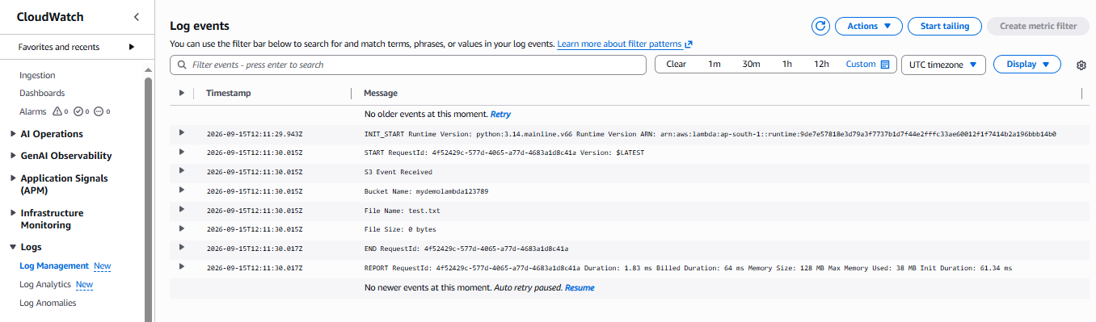

Backup file from one bucket to another bucket
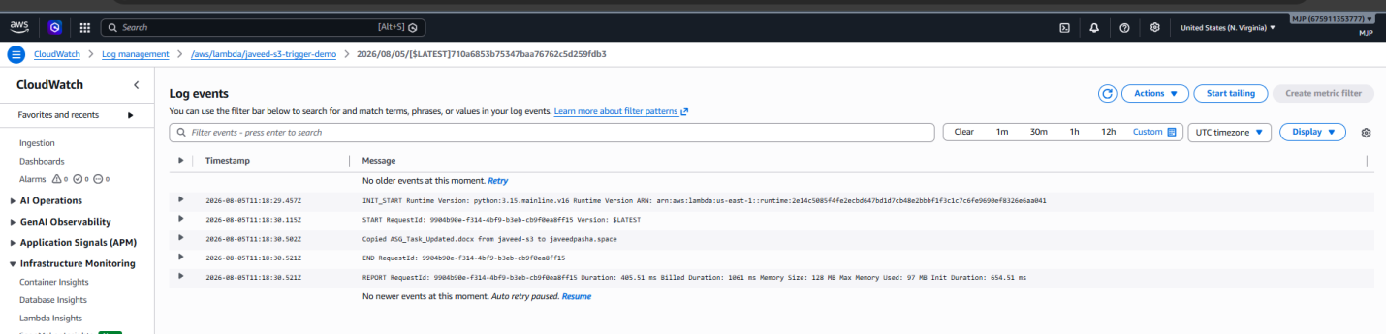

API Gateway

What is API Gateway?
Amazon API Gateway is a fully managed AWS service that allows developers to create, publish, secure, monitor, and manage APIs. It acts as the entry point for applications to communicate with backend services such as Lambda, EC2, ECS, or other HTTP services.

Simple Definition
API Gateway is like a receptionist. It receives client requests, checks them, and forwards them to the appropriate backend service.

Why do we use API Gateway?
Without API Gateway:
- Users cannot directly and securely access Lambda or other backend services.
- You would need to build your own web server to receive HTTP requests.
With API Gateway:
- Provides a secure HTTP/HTTPS endpoint.
- Handles authentication and authorization.
- Supports request validation.
- Can throttle requests to protect backend services.
- Integrates directly with Lambda.

Where is API Gateway used?
- Mobile applications
- Web applications
- Microservices
- Serverless applications
- Third-party integrations
- IoT applications

Step-by-Step Flow
- Client sends an HTTP request.
- API Gateway receives the request.
- API Gateway authenticates and validates it.
- API Gateway forwards it to Lambda.
- Lambda processes the request.
- Lambda returns the response.
- API Gateway sends the response back to the client.

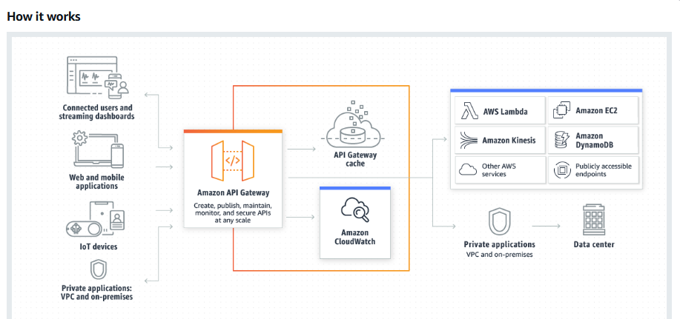

Advantages
- Fully managed
- Highly scalable
- Secure
- Supports REST and HTTP APIs
- Integrates with Lambda
- CloudWatch monitoring
- IAM authentication
- JWT authentication
Sure bro. Here are 2 simple API Gateway hands-on tasks that are good for AWS beginners and interviews. Both can be completed using the AWS Console.

Task 1: Create a REST API and Return "Hello World"

Objective :
The objective of this task is to:
- Create an API Gateway REST API.
- Create a simple GET method.
- Configure a mock integration to return a response.
- Deploy the API to a stage.
- Test the API using a browser.

Prerequisites :
- Active AWS account.
- IAM permissions for:
  - API Gateway
- Basic understanding of:
  - HTTP
  - GET method
  - REST API
- AWS Console access.
- No Lambda function is required for this task.

Step-by-Step Implementation :

Step 1: Open API Gateway
- Login to AWS Management Console.
- Search for API Gateway.
- Open Amazon API Gateway.
- Click Create API.

Step 2: Create REST API
Select:
REST API
Click Build.
Enter:
API name: MyDemoAPI
For endpoint type, select:
Regional
Click Create API.

Step 3: Create a Resource
In the API Gateway console:
- Click Create Resource.
- Enter:
Resource Name: hello
Resource Path: /hello
- Click Create Resource.
You will have:
/
└── /hello

Step 4: Create GET Method
Select /hello.
Click:
Create method → GET
For integration type, select:
Mock
Click Create method.
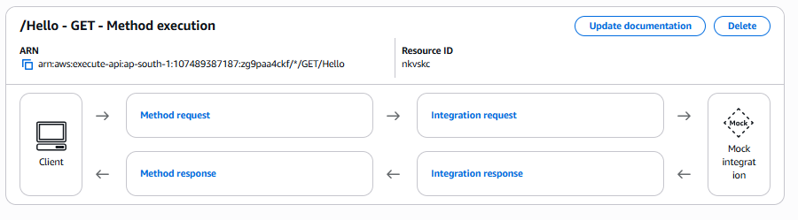

Step 5: Configure Response
Go to the Integration Response section.
Configure the response body, for example:
{
"message": "Hello World from API Gateway"
}

Step 6: Deploy the API
Click:
Deploy API
Create a new stage:
Stage name: dev
Click Deploy.
Invoke URL :
https://zg9paa4ckf.execute-api.ap-south-1.amazonaws.com/dev

Step 7: Test
Open the URL in your browser.
Expected response:
{
"message": "Hello World from API Gateway"
}

Result :

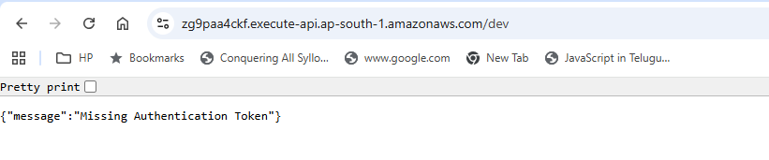
You successfully created:
Client
↓
API Gateway
↓
GET /hello
↓
Mock Integration
↓
"Hello World"

Task 2: Create API Gateway + Lambda Integration
This is a little more realistic and is a very useful DevOps/AWS interview scenario.

Objective :
The objective of this task is to:
- Create a Lambda function using Python.
- Create an API Gateway API.
- Connect API Gateway to Lambda.
- Invoke Lambda through an HTTP endpoint.
- Verify the response in the browser.

Prerequisites :
You need:
- Active AWS account.
- IAM permissions for:
  - Lambda
  - API Gateway
  - CloudWatch Logs
- Basic Python knowledge.
- Basic understanding of HTTP GET requests.

Step-by-Step Implementation

Step 1: Create Lambda Function
Open:
AWS Console → Lambda
Click:
Create function
Select:
Author from scratch
Enter:
Function name: MyAPILambda
Runtime: Python 3.x
For execution role, select:
Create a new role with basic Lambda permissions
Click:
Create function

Step 2: Add Python Code
In the Lambda code editor, use:
import json

def lambda_handler(event, context):
return {
"statusCode": 200,
"body": json.dumps({
"message": "Hello from Lambda through API Gateway"
})
}
Click:
Deploy

Step 3: Create API Gateway
Open:
API Gateway → Create API
Select:
REST API
Click:
Build
Enter:
API name: MyLambdaAPI
Endpoint Type: Regional
Click:
Create API
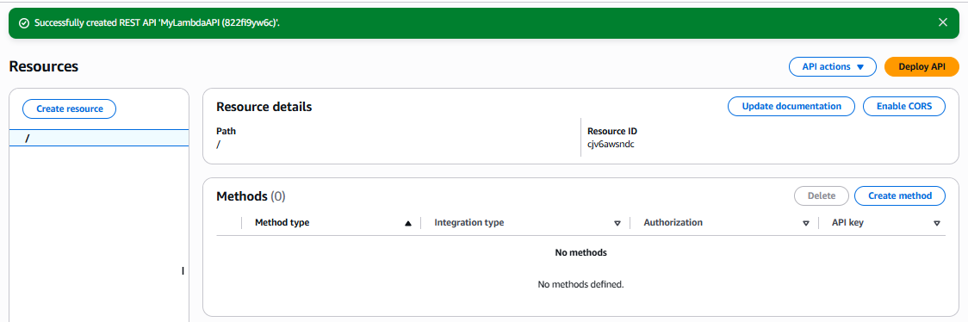

Step 4: Create Resource
Create:
Resource Name: hello
Resource Path: /hello
You will have:
/hello

Step 5: Create GET Method
Select /hello.
Click:
Create method → GET
For Integration type, select:
Lambda Function
Select your Lambda:
MyAPILambda
Enable:
Use Lambda Proxy integration
Click Create method.
AWS may ask for permission for API Gateway to invoke the Lambda function.
Click Allow.

Step 6: Deploy API
Click:
Deploy API
Create a stage:
Stage name: dev
Click:
Deploy
You will get an Invoke URL similar to:
https://822fi9yw6c.execute-api.ap-south-1.amazonaws.com/dev

Step 7: Test the API
Open the URL in your browser.
Expected response:
{
"message": "Hello from Lambda through API Gateway"
}

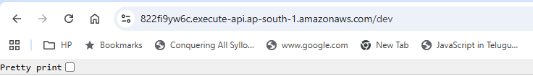
🔄 Understand the Real-Time Flow
User / Browser
|
| HTTP GET
↓
API Gateway
|
| Invoke
↓
AWS Lambda
|
| Python execution
↓
Lambda Response
|
↓
API Gateway
|
↓
User / Browser

AWS KMS (Key Management Service)

What is AWS KMS?
AWS KMS is a managed encryption service used to create and manage encryption keys for protecting data stored in AWS.

Simple Definition
AWS KMS is a secure locker that stores encryption keys and uses them to encrypt and decrypt sensitive information.

Why do we use KMS?
Sensitive data should not be stored in plain text.
Examples:
- Passwords
- API Keys
- Bank Account Numbers
- Credit Card Details
- Database Passwords
- Secret Tokens
KMS encrypts this information before storage.

Where do we use KMS?
- S3
- EBS Volumes
- RDS
- Dynamo DB
- Secrets Manager
- Lambda Environment Variables
- EFS
- Custom Applications

How does KMS work?

Application
│
Encrypt
│
AWS KMS
│
Encrypted Data
│
Store in Database/S3

Advantages
- Fully managed
- Automatic key rotation
- High security
- IAM integration
- CloudTrail logging
- Supports symmetric and asymmetric keys

Complete Architecture
Client
│
HTTP Request
│
API Gateway
│
Lambda
│
Encrypt Data
│
AWS KMS
│
Encrypted Data
│
S3 / RDS / DynamoDB

Task 1 — Create a Customer Managed KMS Key

Objective
To create a customer managed AWS KMS key, configure its basic settings, and understand how KMS keys are used to encrypt AWS resources.

Prerequisites
- AWS account
- IAM user/role with KMS permissions
- AWS Management Console access
- AWS Region selected, for example:
ap-south-1 (Mumbai)

Step-by-Step Implementation

Step 1 — Open KMS
Go to:
AWS Console → KMS
Select:
Key Management Service
Make sure you're in:
ap-south-1

Step 2 — Create a KMS key
In the left navigation:
Customer managed keys → Create key
Select:
Key type:
Symmetric
Click:
Next

Step 3 — Configure key usage
For:
Key usage
Select:
Encrypt and decrypt
Click:
Next

Step 4 — Add alias
Enter:
Alias:
devops-kms-key
Optional description:
KMS key for DevOps lab encryption
Click:
Next

Step 5 — Define key administrators
Select the IAM user/role that should administer the key.
For your lab, select your administrative IAM identity.
Click:
Next

Step 6 — Define key users
Select the IAM user/role that should be allowed to use the key for encryption/decryption.
For the lab, you can select your IAM identity.
Click:
Next

Step 7 — Review and create
Review the configuration.
Click:
Finish
Your key should appear under:
Customer managed keys
Example:
Alias Status
devops-kms-key Enabled

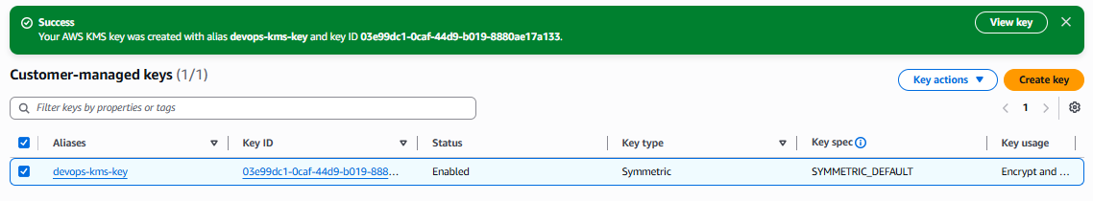

Step 8 — Verify the key
Open:
Customer managed keys → devops-kms-key
Check:
- Key ARN
- Key ID
- Key state
- Key type
- Key usage
- Key administrators
- Key users

Expected Result
KMS Key
|
├── Symmetric
├── Encrypt / Decrypt
├── Enabled
└── Alias: devops-kms-key

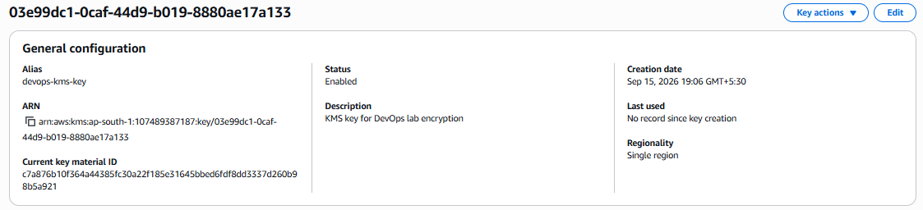

Task 2 — Encrypt an S3 Bucket Using SSE-KMS

Objective
To configure server-side encryption using AWS KMS (SSE-KMS) for an S3 bucket and verify that objects uploaded to the bucket are encrypted using the KMS key.

Prerequisites
- AWS account
- S3 bucket
- KMS key from Task 1
- IAM permissions for S3 and KMS
- AWS Console access

Step-by-Step Implementation

Step 1 — Create an S3 bucket
Go to:
AWS Console → S3 → Create bucket
Enter a unique bucket name, for example:
devops-kms-s3-demo-2026
Choose:
Region:
ap-south-1
Keep the default security settings.
Click:
Create bucket

Step 2 — Open bucket properties
Open your bucket:
devops-kms-s3-demo-2026
Go to:
Properties
Find:
Default encryption
Click:
Edit

Step 3 — Select SSE-KMS
Under encryption type select:
Server-side encryption with AWS Key Management Service keys (SSE-KMS)
For KMS key:
Choose from your AWS KMS keys
Select:
devops-kms-key
For this simple lab, leave the other settings at their appropriate defaults.
Click:
Save changes

Step 4 — Upload a test file
Create a file locally:
kms-test.txt
Put something simple inside:
This is an AWS KMS encryption test.
Then:
S3 → Bucket → Upload → Add files
Select:
kms-test.txt
Click:
Upload

Step 5 — Verify encryption
Open:
kms-test.txt
Go to:
Properties
Look for:
Server-side encryption settings
You should see:
Encryption type:
SSE-KMS
And the KMS key should be your:
devops-kms-key

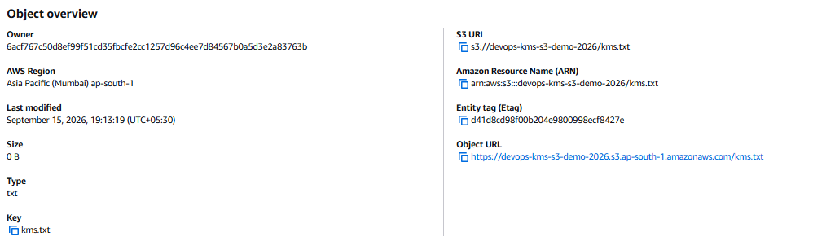

Step 6 — Verify from S3 object details
The object should show encryption information similar to:
Server-side encryption:
AWS KMS

KMS key:
devops-kms-key
Therefore:
User
|
| Upload object
↓
S3 Bucket
|
| SSE-KMS
↓
AWS KMS
|
| Encryption key
↓
Encrypted S3 Object

Important KMS Concepts

AWS managed key vs Customer managed key
Feature | AWS managed key | Customer managed key
Created by | AWS service | You
Key policy control | Limited | More control
Rotation | AWS-managed | Configurable
Deletion control | Limited | You control
Good for lab | Basic | Recommended

SSE-S3 vs SSE-KMS
SSE-S3
S3
↓
AWS-managed encryption

SSE-KMS
S3
↓
AWS KMS
↓
KMS key
↓
Encryption
The main advantage of SSE-KMS is greater control and auditing of key usage, along with integration with IAM and KMS key policies.

